**Insights Derived from K-Means Clustering on College Data**

Once we have clustered the colleges using K-Means, we can analyze the characteristics of each cluster to derive meaningful insights.

**1. Summary Statistics of Clusters:**

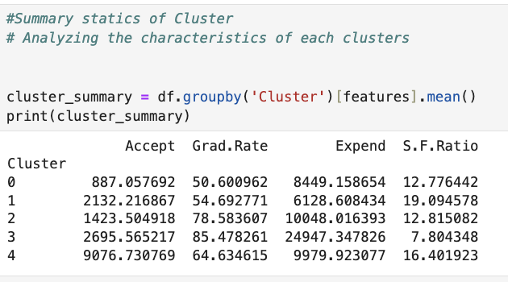

**Cluster 0:** May represent the colleges with **lower Acceptance Rate**

**Cluster 1:** Could be the colleges, with **less tuition fees** and **high Student Faculty Ratio**

**Cluster 3:** May include the colleges, with **higher Graduation Rate and expensive tuition and lower Student Faculty Ratio** .

**Cluster 4:** May include the colleges, with **higher** **Acceptance Rate**

**2. Cluster Size Distribution**

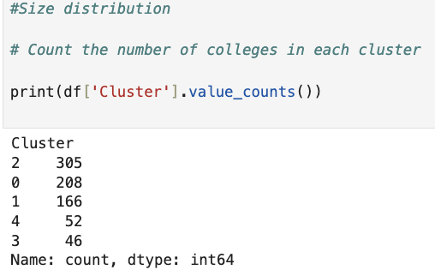

**Cluster 2**: It suggests many colleges share similar characteristics.

**3. Visualizing Cluster Differences**

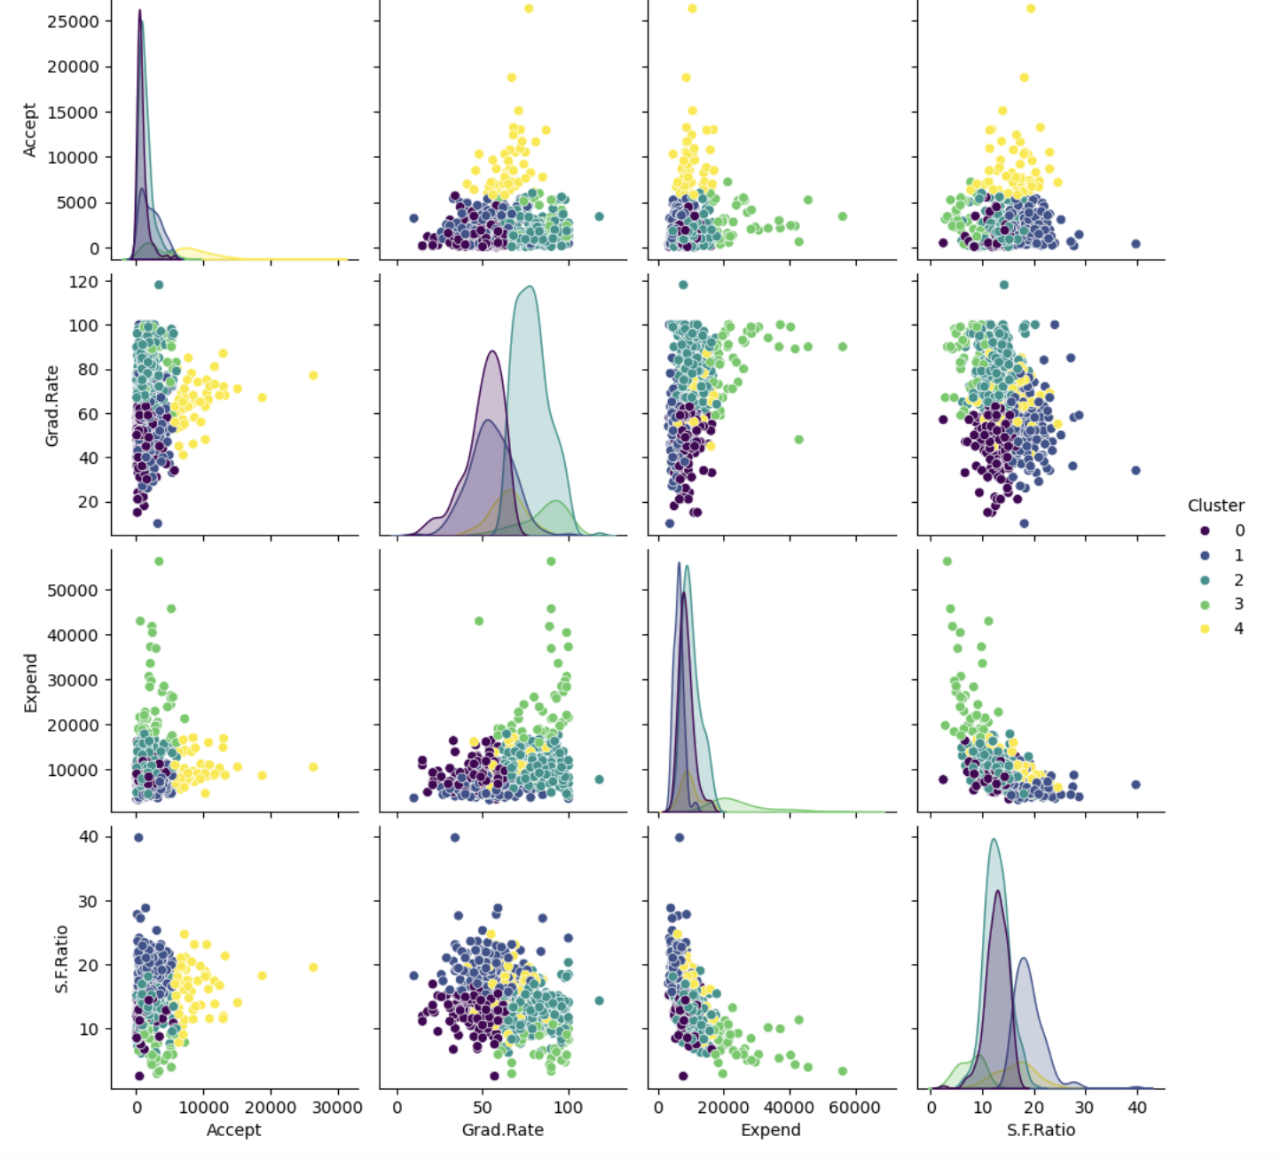

* This helps identify **which features contribute most to clustering**.
* If clusters overlap significantly, it may indicate the need for **more features or different clustering methods** (e.g., hierarchical clustering).

**4. Identifying Representative Colleges**

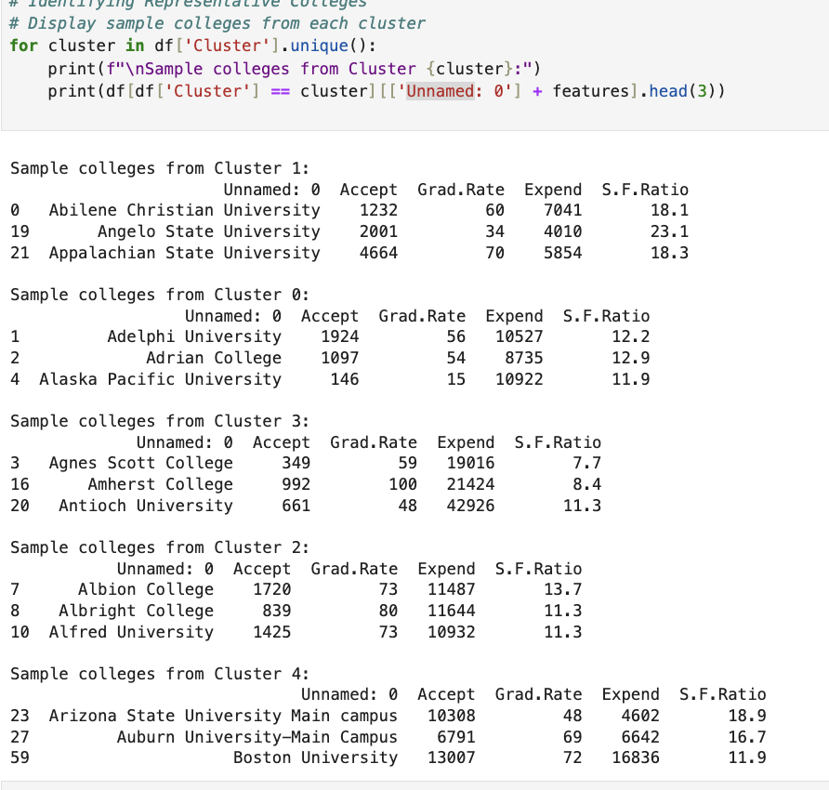

Helps understand which specific colleges belong to each cluster and validate the model.

We can compare against known rankings to verify logical grouping.

**Insights**:

**Which colleges have similar academic standards?** – Clusters can group colleges based on performance metrics.  
 **How does affordability vary?** – Tuition fees can differentiate premium vs. budget-friendly institutions.  
 **Who should target which colleges?** – Helps students understand which group of colleges fits their academic profile.

This clustering method transforms raw college data into actionable insights for students, policymakers, and administrators!